System Architecture Document
School Management System

1. Introduction
The School Management System (SMS) is a web-based application designed to manage school operations such as student management, attendance tracking, fee management, event management, communication, and academic progress monitoring.
The system enables different users including administrators, teachers, parents, and students to access relevant information and perform tasks through a centralized platform.
The architecture is designed to ensure scalability, security, and maintainability using modern web technologies.

2. Architecture Overview
The system follows a Three-Tier Architecture consisting of:
- Presentation Layer – User interface built using React.
- Application Layer – Backend services implemented using Spring Boot REST APIs.
- Data Layer – MySQL database used to store and manage system data.
This architecture separates user interaction, business logic, and data management, making the system modular and easier to maintain.

3. System Architecture Diagram
High-level architecture of the system:
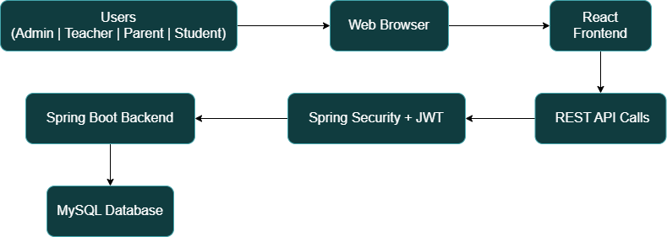

The frontend communicates with the backend through REST APIs, while the backend interacts with the database to retrieve and store information.
4. Technology Stack
Layer | Technology
Frontend | React, CSS
Backend | Spring Boot
API Communication | REST APIs
Database | MySQL
Authentication | JWT
Security | Spring Security
API Testing | Postman

5. System Components
5.1 User Registration and Management:
- Allow students, parents, teachers, and administrators to register and create accounts.
- Maintain records of all registered users, including roles and permissions.
5.2 Class and Schedule Management:
- Create and manage class schedules and timetables.
- Assign teachers to classes and manage class capacities.
5.3 Attendance Management:
- Track student and teacher attendance.
- Generate attendance reports and notify parents.
5.4 Exams and Grades Management:
- Schedule exams and manage grading.
- Provide students and parents with access to grades and progress reports.
5.5 Communication and Notifications:
- Facilitate communication between teachers, parents, and students.
- Send notifications about school events, exams, and other updates.
5.6 Educational Resources:
- Provide access to learning materials, assignments, and resources.
- Allow teachers to upload and share resources.
5.7 Fee Management:
- Manage student fee payments and generate invoices.
- Track payment history and send reminders.
5.8 Event Management:
- Plan and organize school events and activities.
- Manage event registrations and track participation.
5.9 Data Security and Privacy:
- Ensure secure storage and access of user data.
- Comply with data privacy regulations.
5.10 Administrator Dashboard:
- Provide real-time metrics on attendance, grades, and school activities.
- Generate reports for decision-making.

6. Backend Architecture (Spring Boot)
The backend follows a layered architecture.
- Controller Layer
- Service Layer
- Repository Layer
- Entity Layer
- Security Layer

  - Controller Layer
Handles HTTP requests and exposes REST API endpoints.
Example endpoints:
/api/auth/login
/api/students
/api/fees
/api/events
/api/attendance

6.2 Service Layer
Contains business logic and processes system operations.
Examples:
- Calculate fee balance
- Validate event registrations
- Process payments

6.3 Repository Layer
Handles database interactions using Spring Data JPA.
Example repositories:
- UserRepository
- StudentRepository
- FeeRepository
- EventRepository

6.4 Entity Layer
Represents database tables as Java objects.
Example entities:
- User
- Student
- Fee
- Payment
- Event
- Attendance

6.5 Security Layer
Handles authentication and authorization using Spring Security and JWT tokens.

7. Database Architecture
The system uses MySQL for data storage.
Main tables include:
Table | Description
Relationships:
An Entity Relationship Diagram (ERD) represents these relationships.

8. Security Architecture
Security is implemented using JWT authentication and Spring Security.
Authentication
Users log in using credentials.
The backend generates a JWT token upon successful authentication.
Authorization
Access to system resources is controlled using role-based access control (RBAC).
Example roles:
Role | Access
Administrator | Full system access
Teacher | Manage attendance and resources
Parent | View student progress and fees
Student | Access resources and events

Token-Based Security
All API requests include a JWT token:
Authorization: Bearer <JWT_TOKEN>
Spring Security validates the token before allowing access to protected resources.

9. Data Flow
Example flow for viewing fee details:
- Parent logs into the system.
- React frontend sends request to backend API.
- Backend verifies JWT token.
- Backend retrieves fee data from MySQL.
- Backend sends response to frontend.
- React displays the fee details to the parent.

10. API Testing
The system APIs are tested using Postman.
Postman is used for:
- Testing REST endpoints
- Validating request/response data
- Testing authentication tokens
- Debugging backend services

11. Conclusion
The School Management System architecture provides a secure, scalable, and modular solution for managing school operations. By using modern technologies such as React, Spring Boot, REST APIs, and JWT authentication, the system ensures efficient communication between the frontend, backend, and database layers while maintaining high security and performance.

